**IASTracker**

Operations Manual

(IAS Tracker operations manual v0.3)

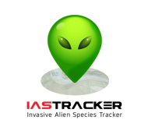

**Project by:** IC5Team

**Contact**: Ms. Blanca Botey

**e-mail:** ic5team.co@gmail.com

Table of Contents

[1. INTRODUCTION 2](#_Toc431259987)

[2. IASTRACKER APP 3](#_Toc431259988)

[2.1 SPLASH SCREEN 3](#_Toc431259989)

[2.2 IASTRACKER TERMS AND CONDITIONS AGREEMENT 3](#_Toc431259990)

[2.3 NAVIGATE THROUGH IASTRACKER MENU 4](#_Toc431259991)

[2.4 IDENTIFY AN IAS AND SEND LOCATIONS 5](#_Toc431259992)

[3. PROCEDURES 5](#_Toc431259993)

[3.1 ADD AN IAS 6](#_Toc431259994)

[3.2 ADD AN IAS AREA 8](#_Toc431259995)

[3.3 VALIDATING OBSERVATIONS 10](#_Toc431259996)

[3.4 USER MANAGEMENT 10](#_Toc431259997)

[3.5 TRANSLATION 11](#_Toc431259998)

[Annex I. IAS Tracker DATA DICTIONARY 13](#_Toc431259999)

# 1. INTRODUCTION

This document describes de functionalities of the IASTracker App, the Smartphone application that takes observations of Invasive Alien Species (IAS) developed by IC5Team. The document also describes the main procedures that are needed to scale and maintain the IASTracker project, that accessible from the IASTracker geoportal.

# 2. IASTRACKER APP

IASTracker Mobile App is the tool which will enable the user to submit geo-located information (location, photos and notes) of IAS. The user will be able to identify the IAS through the IAS datasheets, which will guide the user in the identification of the specimen.

This section describes the main App processes ordered by the natural flow.

## 2.1 SPLASH SCREEN

IASTracker displays the splash screen when launching the App, while its is shown the App downloads the datasheets in background. This large initial download occurs first time the user launches the App, after that when user launches the app only the new datasheets are download if needed. IASTracker App uses user location data, so after downloading the datasheets, it will be checked that location services are turned on, otherwise, the user will be asked to enable Location Services on his device and give permission to IASTracker App to use location data.

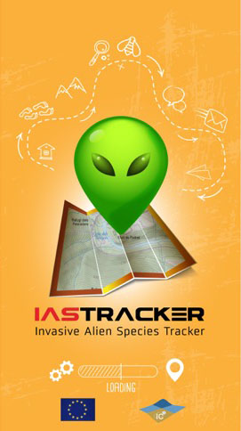

## 2.2 IASTRACKER TERMS AND CONDITIONS AGREEMENT

User agreements of IASTracker Terms and Conditions is mandatory. And those agreements have to be shown previous to start using the App.

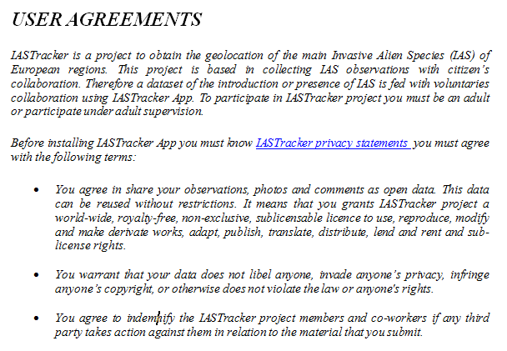

**2.3 REGISTRATION**

To use the app, the user does not need to register IASTracker project. However, having an IASTracker account provides some advantages, like having a personalizedfavorite IAS list, a list of IAS areas (crec que ho pot fer encara que no estigui registrat), a dashboard with some management options which allows some operations in the IASTracker geoportal.

By default the user is asked to createan IASTracker account the first time the application is started. After this quick registration, a confirmation email is sent to the new user and the acceptation of the request will close the account creation procedure.

If the user rejects the creation of an account the first time, It will be always possible to register in a future through an option in the App menu.

***IMATGE REGISTRE***

## 2.3 NAVIGATE THROUGH IASTRACKER MENU

IASTracker user can access to IASTracker App functions through the menu. Tap the menu icon menu_boto.png or swipe to the right on the screen to view the options. Swipe to the left on the screen to hide the menu.

***IMATGE MENÚ***

**General rules:**

Click on the IAS picture to see its datasheet and identify it.

Tap the star below IAS picture to mark or unmark an IAS as starred.

**IASTracker menu:**

* IAS current location: List of IAS around the user current location.

**IMATGE DE IAS CURRENT LOCATION**

* My IAS: List of starred IAS, favorite list - for registered users only.

**IMATGE MY IAS**

* Taxonomic groups: Select an IAS by taxonomy. At the bottom of the screen there is the name of the selected taxonomy. Each taxonomy group has an assigned colour. Scroll up/down the screen if you want to see other taxonomic groups.

**IMATGE DE GRUPS TAXONS**

* IAS user lists by area: Select an area, not necessarily the current one, to generate a new IAS list of this specific area. This new list will be only seen by the user. Write a name for your new list.

This utility has been designed to allow users to prepare an IAS hunt journey to a location where Data connection won’t be able. When the users arrive to that location, they will be able to use the App offline and select the IAS list of their current location.

**IMATGE DE IAS USER LISTS**

Using IASTracker App offline doesn’t differ from using it online. User only will notice it when sending an observation; a warning message will be shown explaining that the observation will be send when data connection will be restored. And when launching the App (during the splash screen and if data connection is available) the App verifies if there are some pending observation packages, in this case those observation packages will be sent (with confirmation of the user?).

* User Profile: Select User Profile to update user name, email and personal data associated with the user. Change here the password, add a picture, add or change names and surnames, indicate if you are an expert or not and change the language associated to your profile.

**IMATGE USER PROFILE**

* About IASTracker: Brief description about IASTracker project, IC5Team and the App Acknowledgements..
* About IC5Team: Brief description about IC5Team.
* Scientific name: Turn on scientific name if you want to see the IAS scientific names and turn it off if you want to see common names.
* Help: Brief help to use the App.

## 2.4 IDENTIFY AN IAS AND SEND LOCATIONS

**IAS DATASHEETS:**

Tap an IAS picture to see its datasheet and identify it. IAS datasheets contain some pictures of IAS, a brief general description about the IAS, as well as a more specific descriptions about IAS sizes, habitat, further information and potential confusions with other species. Each datasheet has the colour of its associated taxonomy.

At the bottom of the screen appears the common name of the species, followed by the scientific name. Next to the names the user can mark the IAS as starred.

Below the names appears some IAS pictures. Swipe to the right/left on the pictures to see more pictures. Tap a picture to zoom it in.

Next, the user can locate the IAS. Tapping in "LOCATE IAS", the user access to IAS location screen.

Finally, there is the IAS description. Scroll down the description to continue reading the description.

Swipe to the right / left on the datasheet to see other IAS datasheets.

**IMATGE D'UNA FITXA**

**IAS LOCATION**

Access to "IAS LOCATION" screen through IAS Datasheets. The user can send the location of an IAS here. At the bottom of the screen there is the current name of the IAS. Below there is the user current location. The user can zoom in or zoom out the map, and change the basemap. Tap on "SEND IAS" to send the current location of the IAS. Once the user send the location the observation cannot be modified by the user.

The user can also take a picture of the IAS or select a picture from the device library. It is also possible to add a note or indicate the number of specimens that the user sees in the current location. Tap on "Add a note" and "Number of specimens" to add that information. This information is optional for registered users, but attaching a picture is mandatory for none registered users, considering that it is the only way the validator has to certify the observation.

**IMATGE D'UNA PANTALLA D'IAS LOCATION**

# 3. PROCEDURES

This section describes the main procedures needed to manage the IASTracker project and the procedures needed to scale this project to other regions.

## 3.1 ADD AN IAS

Add a new IAS requires preparing some data and planning how this new IAS will be validated. It is supposed the managers of the IAS Tracker project have selected a new IAS because it fulfils some of IAS Tracker requirements: it must be easily identifiable, it must have an obvious impact (ecological, economical or in citizens’ health), otherwise it must help to make citizens aware of IAS risks.

*PREVIOUS STEPS*

Data for the PostgreSQL database:

* For IAS table are necessary, obviously, the attributes described in the Annex I IAS Tracker dictionary. In the following are explained any especial characteristic apart from the already explained in the Annex I.
  + Scientific name. It can be the scientific name of the specie, but also it can be a genus. In IAS Tracker prototype, it’s included Indian Fig (*Opuntia ssp.*) that matches a group of different Opuntia that are hard to distinguish one species from another. It does not avoid to able to create a new IAS of a specific e.g. *Opuntia microdasys*.
  + Taxon. The IAS Tracker taxa list is not exactly an exhaustive Taxonomy classification. Is thought for create a clear list of groups easily identifiable by ordinary citizens.
  + Order. This number is the order the IAS is shown in the App (it also depends on which the priority of the regions)
* For IASDescriptions table are necessary to know how many languages are available in IASTracker. IAS description must be translated to all languages. If for any chance the App doesn’t find a description in a specific language, the English description is shown, so without this description the IAS wouldn’t be available for the App.
  + Name. Sometimes specie has a lot of common names. At the moment IAS Tracker accepts comma separated names.
  + ShortDescription. A text description not more than 450 characters (blanks included) length with the main characteristics to IAS identification.
  + DescriptionMida. The measurements units (if needed) must to be given in the International system of units. It’s also important to remember that different countries designate different symbols for the decimal mark and thousands separator.
  + DescriptionInfo. It can describe widely how is the specimen, where does it come from, any special characteristic, their main impacts, ...
  + DescriptionHabitat. Habitats where the IAS can live, where can be found,...
  + DescriptionSimilities. Not be confused with text, is there are other species similar to the IAS it would be useful have a plain description of how to distinguish it.
* For IASRelatedDB table is optional to find links to help a wide description of the IAS. The external repositories of IAS or biological data are included in the Repositories table; it’s not a closed list.
* For IASRegions table is necessary to know in which of the regions has to be located. An IAS not matched to any region only will be available by the taxa query in the App; an IAS matched with a region will be available in the App default IAS list if the user is located in the regions, otherwise, always will be available by the taxa query.
* For the IASImages table is necessary to have for each image:
  + Credits. Name or nickname of the author. If this field is left blank it is understood that the author is IAS Tracker project collaborators or managers.
  + License. License information. If this field is left blank it is understood that license is the general license for IASTracker datasheets (pending to be described in about the project)
  + Link. Link to the material. If this field is left blank it is understood that the owner of the image is IASTracker there isn’t any external link.
* For the IASImagesText table is necessary to have for each image and language a description of the image. If for any chance the App doesn’t find a description in a specific language, the English description is shown.
* For the IASRegionsValidator table is necessary to know which validator will be in charge of the IAS obsarvations.

External data linked to the PostgreSQL database:

The images of the datasheets are located into the ...\IASimages folder. These images have been scaled and resized to obtain a 1090 x 820 pixel image. These dimensions have been selected because are the best for IASTracker App design.

*ADDING IAS USING PGADMIN*

1. Copy datasheet images to ...\IASimages folder
2. Open pgadmin
3. Select IASTracker database. password
4. Select IAS table and select the edit grid tool. As far as this tool doesn’t allow seeing joined data, is a bit tricky to know taxonId value. In case of using this method it would be useful to query previously IASTaxons table. Create new row.
5. Select IASDescriptions table and select the edit grid tool. As far as this tool doesn’t allow seeing joined data you have to known previously the language Id. In case of using this method it would be useful to query previously Languages table. Create new rows.
6. Select IASRelatedDB table and select the edit grid tool. As far as this tool doesn’t allow seeing joined data you have to known previously the Repository Id. In case of using this method it would be useful to query previously Repositories table. Create new rows.
7. Select IASRegions table and select the edit grid tool. As far as this tool doesn’t allow seeing joined data you have to known previously the Regions Id. In case of using this method it would be useful to query previously Regions table. Create new rows.
8. Select IASRegions table and select the edit grid tool. As far as this tool doesn’t allow seeing joined data you have to known previously the Regions Id. In case of using this method it would be useful to query previously Regions table. Create new rows.
9. Select IASImages table and select the edit grid tool.. Create new rows.
10. Select IASImagesText table and select the edit grid tool. As far as this tool doesn’t allow seeing joined data you have to known previously the IASImages Id created in the previous point. Create new rows.
11. Select IASRegionsValidator table and select the edit grid tool. As far as this tool doesn’t allow seeing joined data you have to known previously the validator users Id and the Regions Id. In case of using this method it would be useful to query previously these tables. Create new rows.

*ADDING IAS USING IASTRACKER GEOPORTAL*

1. Enter IASTracker geoportal with an administrator user
2. Select IAS form

**IMATGE D'UNA PANTALLA**

1. Click on Add new IAS and enter the scientific name
2. Select descriptions subform and add new common names and descriptions by language

**IMATGE D'UNA PANTALLA**

1. Select images form and drag and drop images. Then end filling table values

**IMATGE D'UNA PANTALLA**

1. Select regions form and mark in which regions will be attached the IAS.

**IMATGE D'UNA PANTALLA**

1. Select validator form and mark which validators will be able to validate these IAS observations.

**IMATGE D'UNA PANTALLA**

If it’s necessary to detach an IAS it can be done entering an administrator user and using the delete option. This option doesn’t delete the IAS from the database, it update *delete\_at* field.

## 

## 3.2 ADD AN IAS AREA

An IAS Area can be a polygon, representing a country, a region, a city, a natural park, etc. IAS species are attached to these areas to enable IASTracker App to provide a specific list of IAS depending on the user is located. IASTracker App when launched gets the user location and then searches the areas that intersect with this location. All species attached to these areas are shown in the IAS list screen.

Different areas can overlap, e.g. there is an initial area for Catalonia, this area has attached widespread IAS; and there is an area located at Ebro Delta (in Catalonia) which has attached only one species, the apple snail. Someone using the App in Ebro Delta will see the apple snail in the list of IAS and also the Catalonia Area IAS; if they move outside this area, the apple snail will not be shown in the list.

Nevertheless, the user can always make an IAS observation of an IAS that is not attached to their location; they can user a shortcut querying IAS by taxa. That option has been left open, because of the nature of IAS, their distribution evolves continuously and this flexibility cannot be restricted by IASTracker App. Any restriction will stop detecting changes in AIS distribution, and this is opposite of the goals of IASTracker project.

*PREVIOUS STEPS*

* It’s necessary to use GIS software (e.g. Quantum QGIS) to create or import a layer with the geometry of the area.

*USING QGIS TO ADD A NEW AREA*

* Launch QGIS and open a postgis connection to IASTracker database, administrator permissions are required.
* Add Areas layer from IASTracker database
* Add the layer containing the new area (source layer)
* Select Areas layer and *Toggle editing.*
* Select the new area in the source layer and paste it in the Areas layer.
* Open Areas layer and update the fields: iasrid, name, description. Iasrid is the key used to relate Areas with IAS.
* Save layer edits

*ADDING IAS USING IASTRACKER GEOPORTAL*

**IMATGE D'UNA PANTALLA**

* Launch QGIS and add the layer containing the new area (source layer).
* Select the polygon
* Copy features
* Enter to IASTracker geoportal with an administrator user
* Select the Area form
* Select the Add new area button
* Update the name, descripction and id of the IAS Area.
* In the geometry field paste the selected polygon. That step pastes the source polygon data (geometry included) in well-known text (WKT). As shown in the following picture.

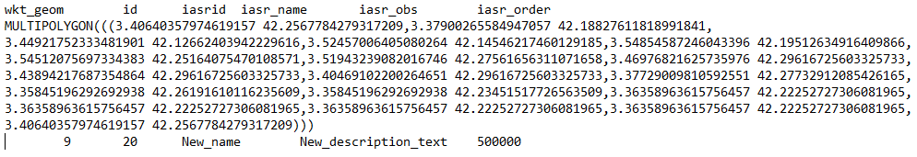

It is necessary to leave only the geometry text, like next image example.

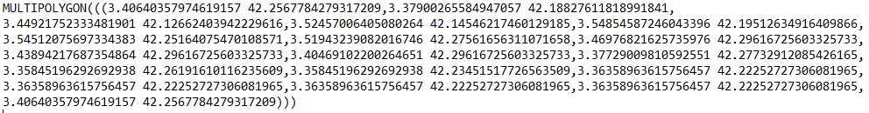

* Validate the changes

In order to optimize geoportal queries by countries, this process also updates a relation table between areas and countries.

## 3.3 VALIDATING OBSERVATIONS

The statuses of the observations are three:

* Pending to be validated. It is the initial status of the observations. There is one exception, administrators users can mark other user for automatically validate their observations, and this is thought to be used with IAS specialists or other experts.
* Validated. Validators users revise the observation notes, images, locations and can mark an observation as validated. They can also add a comment to the user.
* Not validated. IF there is not enough information or the information is clearly wrong, validators users mark the observation as not validated, and they must add a comment to the user.

*VALIDATION PROCESS STEPS*

* Enter IASTracker geoportal with an validator user
* Select Validators IAS list form

**IMATGE D'UNA PANTALLA**

* Select only show non validated observations
* Click on the observation
* Revise images, comments, locations, user statistics, other observations...
* Validate or not validate and comment de validation

Sometimes during this process inappropriate images can be located; in this case the validator can do the following:

* If the data comes from a registered user, the validator will send a message to the administrator user to ask him to send a first warning to the user
* If the data comes from a non registered user, the validator will delete the observation

## 3.4 USER MANAGEMENT

IAStracker define different user profiles, they are:

* Administrator. Can create, delete IAS, areas. Also can reset user passwords, can send warning messages to users, can attachd IAS to regions and validators. They can a user as validator, as expert. And can make all the functionalities of the other users.

**IMATGE D'UNA PANTALLA**

* Validator. Can access to the validator process and has list of IAS attached to him. An also can use the functionalities if the expert an non expert users.

**IMATGE D'UNA PANTALLA**

* Expert. They are IASTracker registered users that automatically have their observations validated. They can access to their observations and change their profile, password, etc. They can send observations with images and without images (only comments)

**IMATGE D'UNA PANTALLA**

* Non expert. They are IASTracker registered users whose observations must to be validated. They can access to their observations and change their profile, password, etc. They can send observations with images and without images (only comments)
* Not registered users. Their observations must include always an image, they cannot be identified, so they cannot change their profile, neither query their observations.

## 

## 3.5 TRANSLATION

To translate IASTracker project to other languages, it’s necessary to translate the following message files:

Geoportal and App messages:

* Create the following files (*XX* means the language Id) in the folder ...\XXXXXX
  + email\_*XX*.php
  + ui\_*XX*.php
  + app\_*XX*.php

These files can be copied from the English ones, or from whatever language is preferred.

IASTracker postgreSQL database messages:

* Enter IASTracker geoportal with an administrator user
* Select export for translation form
* Create the new language Id
* Select in which language is to be created the set of messages
* Export the set of messages. This set of messages include 4 files:
  + IASDescriptions
  + IASImagesText
  + IASTaxons
  + StatusText
  + Hi ha alguna més?
* Translate these files
* Import the set of messages.

# Annex I. IAS Tracker DATA DICTIONARY

Data dictionary for IAS Tracker database.